**INTRODUCTION**

“Restaurant Management System” is web application to restaurant management. This system wake to provide service facility to restaurant and also to the customer. The services that are provided is food ordering and reservation table management by the customer through the system online, customer information management and waiter information management, menu information management and report. Main objective build the system this is to provide ordering and reservation service by online to the customer. With this system online, ordering and reservation management will become easier and systematic to replace traditional system where are still using paper.

Furthermore, this system is applicable any time and where also customer. During the development of ORMS, the methodology being used is Prototyping model. Each process during the development process is followed by each phases in Prototyping model. Software and hardware used are AppServer, Macromedia Dreamweaver 8, Microsoft Visio 2003, Apache server and MySQL database. Furthermore, this project will develop for restaurants management and enhance business in system business by online. Others, this project to facilitate customer for make online ordering and reservation.

Restaurant Management System is a process of ordering food from a restaurant or food co-operative through a web page or app. Much like ordering consumer goods online, many of these allow customers to keep accounts with them in order to make frequent ordering convenient. A customer will search for a favorite restaurant, usually filtered via type of cuisine and choose from available items, and choose delivery or pick-up.

**BACKGROUND HISTORY**

Restaurant management system is the system for manage the restaurant business. The main point of developing this system is to help restaurant administrator manage the restaurant business and help customer for online ordering and reserve table.

The project is developing because many restaurants have a lot difficult to manage the business such as customer ordering and reservation table. By using manual customer ordering is difficult to waiter keep the correct customer information and maybe loss the customer information.

So,online restaurant management system will develop to help the restaurant administrator to manage restaurant management and for customer make their online ordering and reservation table. Other than that,this project is to upgrade the manual system and make the business easily to access and systematic.

**EXISTING SOFTWARE**

Looking for restaurant software to control profitability of your business, you know that now, more than ever, it is critical to understand all your costs and how they relate to your restaurants management of sales. Management in restaurants is one of the most daunting jobs in the restaurant industry. If you are trying to cope with QuickBooks or a series of Excel Spreadsheets, you are undoubtedly spending countless hours making crucial decisions with questionable data. If you are struggling with some other very expensive and complicated form of software.

The Restaurant Professional Software program is a comprehensive restaurant management tool designed for foodservice management of all types. It is simple to learn and easy to use. This system processes transaction and stores the resulting data. Reports will be generated from these data which help the manager to make appropriate business decisions for the restaurant. For example, knowing the number of customers for a particular time interval, the manager can decide whether more waiters and chefs are required. Restaurant Software Systems are essential to the successful operation of most foodservice establishments because they allow the business to track transactions in real-time.

This software can be called in any of the following names:

• Restaurant kitchen management system

• Hotel management system

• Restaurant management system

• Restaurant inventory management system

• Restaurant production management system

• Restaurant inventory and production cost control management system

• Restaurant chain management system

• Hotel chain management system

**REQUIREMENT ANALYSIS**

**Functional Requirement:**

**Customer Maintenance:**

• This system must allow users to add new member, update’s member details, delete and search for existing member details.

**System Requirement:**

➢ The system must allow the user to enternew member details.

➢ The system must allow the user to enter desirable username.

➢ The system must validatethe details enter by user such as IC Number, Phone Number, Email and so on.

➢ If the user enters invalid member details, an error message will be promptand user needs to re-enter the invalid details.

➢ If the member details are valid, the system will prompta confirmation message.

➢ If user clicks on confirm button, the system will displaya successful message, storethe details into database and an email will be sent**.**

**Menu Maintenance:**

• This system must allow users to add new items, update’s item details and search for existing item details.

**System Requirement:**

➢ The system must allow the user to enternew item details.

➢ The system must be able to generatea new item ID.

➢ The system must validat**e** the details enter by the user.

➢ If the user enters invalid item details, an error message will be prompt and user needs to re-enter the invalid details.

➢ If the item details are valid, the system will prompta confirmation message.

➢ If user clicks on confirm button, the system will displaya successful message and **s**torethe details into the database.

**Customer Order :**

• The system allows user to add new order details, update order details, remove an order, check and search for existing order details.

**System Requirement :**

➢ The system must allow the user to enternew order details.

➢ The system must be able to generatea new order ID.

➢ The system will prompt a confirmation message when the user clicks on “Confirm” button.

➢ If user clicks on confirm button, the system will displaya successful message and storethe details into the database.

➢ The system shall createa new payment details for each new order stored.

➢ The system will display the order details on kitchen screen.

➢ The system must allow the user to enter a specific input such as order ID for searching purpose.

➢ The system shall displaythe searching result if found in database.

➢ If the item details cannot be matched in the database, the system will promptan error message.

➢ The system shall allow the user to reenterthe searching details.

**Non-Functional Requirement:**

**Usability:**

Usability quality attributes measures the degree of how satisfaction of the user when they use the system in term of meeting their requirements, intuitive to use and easy to navigate (MSDN, n.d.). The Restaurant Management System must be able to meet the end users requirements so that the end users can carry out their work effectively and will not resist the system. The Restaurant Mobile Application must be designed in a user familiar way so that the mobile users can use it intuitively without excessive training or guidance required.

**Availability:**

Availability quality attributes measures the percentages of system downtime over a predefined period of time (MSDN, n.d.). It can be defined as the proportion time which the system is operating and data are available as needed. RMS is an online system and therefore it is important to ensure that the system is highly available for its end-user such as restaurant staff when they need it for the restaurant business transaction. In other words, the staffs must be able to access the system all the time and obtain the services or information that they want.

**Conceptual integrity:**

Conceptual integrity quality attributes defining the consistency and coherence among the components or modules designed (MSDN, n.d.). It is important to maintain the consistency among the modules designed as the Restaurant Management System (RMS) is made up from 7 modules. If consistency does not practice, it would require a longer time for the technician to carry out system maintenance and system upgrade due to different programmer for each module will have a different variable declaration for the same specific input and coding styles.

**Understandability:**

Understandability quality attributes measures the degrees of the project team‟s understanding towards the system’s purpose and requirements at the end of the initiation phase (Anon., 2009). The duration of completing the RMS project is a three month project which is a tight schedule. It is important for the project team understand the problem that proposed by the client and come out with solutions that does not need to change the business nature of the client. Besides, it also prevents any frequent changes in the project during the development of the client.

**Portability:**

Portability quality attributes measure the ability of the system to operate in different computing environments (Computer Hope, n.d.). The Restaurant Management System is an online system that will be using web hosting services which allows the restaurant staff access to the system through any web browser from any computing devices at any time with Internet availability.

**Interoperability:**

Interoperability quality attributes measures the ability of two or more systems to communicate and cooperate at runtime by exchanging information and use the information exchanged for their operations (MSDN, n.d.). In this project, Restaurant Management System and Restaurant Mobile Application will be implemented. It is important to ensure that both of the system can communicate to each other and exchanging information as the orders that taken from Restaurant Mobile Application will be displayed in the kitchen module of Restaurant Management System

**RELATIONAL MODEL**

In relational model, the data and relationships are represented by collection of inter-related tables. Each table is a group of column and rows, where column represents attribute of an entity and rows represents records.

***Relation with Customer, Order and Item Table:***

|  |
| --- |
| Customer |
| Customer Id |
| Name |
| Mobile |
| Address |

|  |
| --- |
| Item |
| Item no |
| Name |
| Price |
| Quantity |

|  |
| --- |
| Order |
| Customer Id |
| Item No |
| Order No |

***Relation with Manager,Waiter,Chef and Restaurant:***

|  |  |  |  |  |  |  |
| --- | --- | --- | --- | --- | --- | --- |
| Manager |  |  | Waiter |  |  | Chef |
| Manager Id | Waiter Id | Chef Id |
| Name | Name | Name |
| Mobile | Address | Address |
| Address |  | | |  |

|  |
| --- |
| Restaurant |
| Employee Id |
| Name |
| Address |
| Designation |
| Salary |

**E-R DIAGRAM** 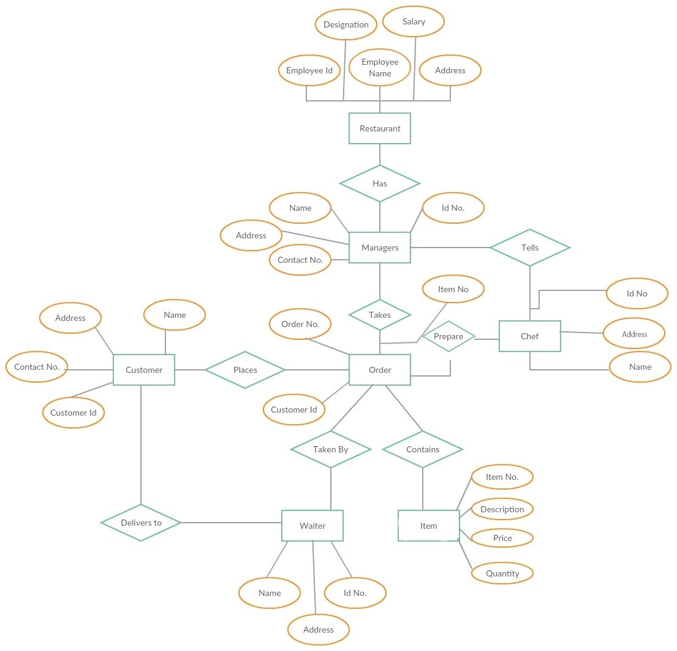

**TABLE CREATE WITH VALUE**

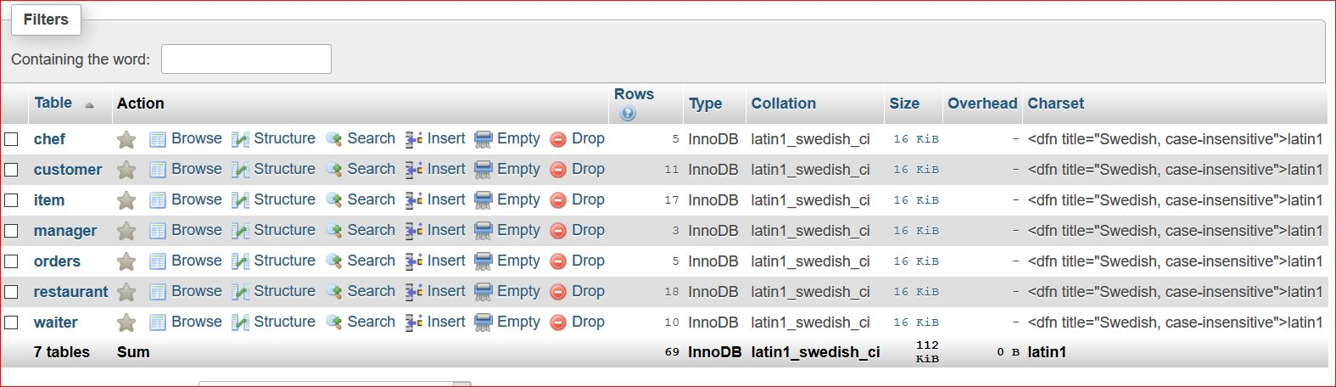

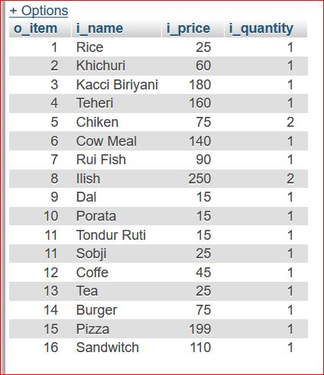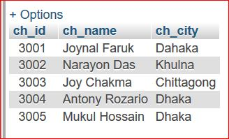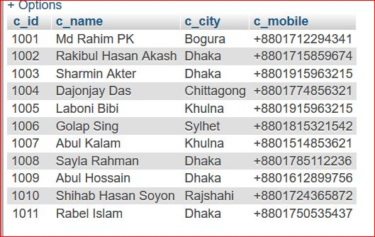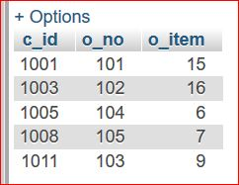

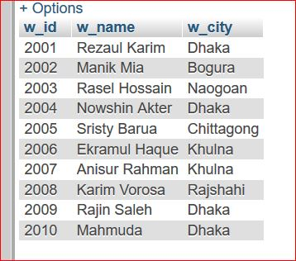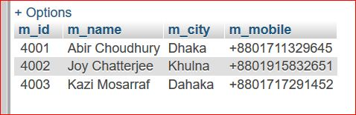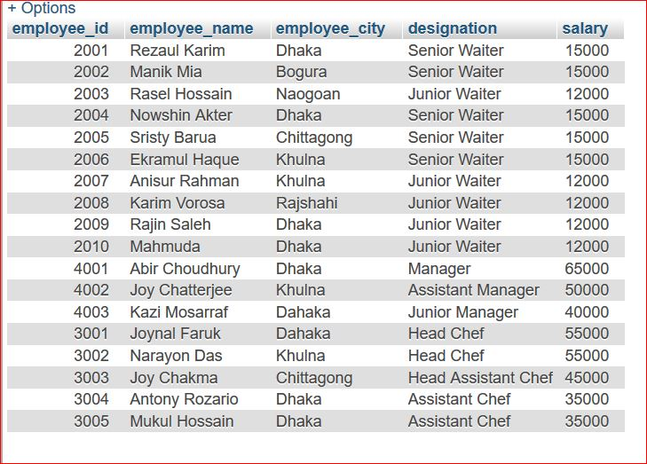

**SNAPSHOTS WITH QUERY AND OUTPUTS**

***Select Query and Output:***

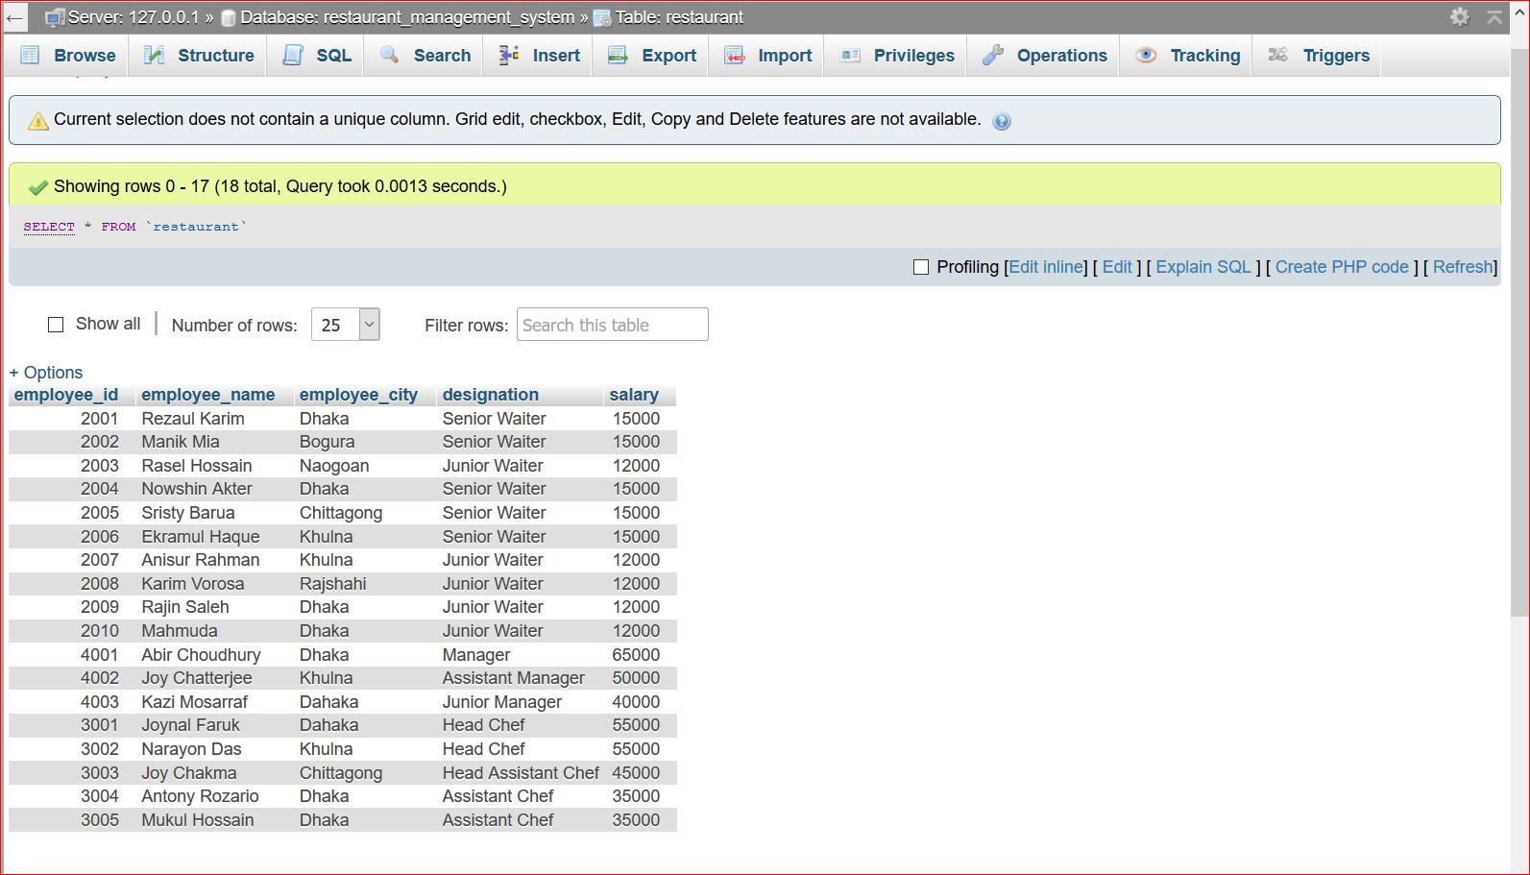

***Case Query and Output:***

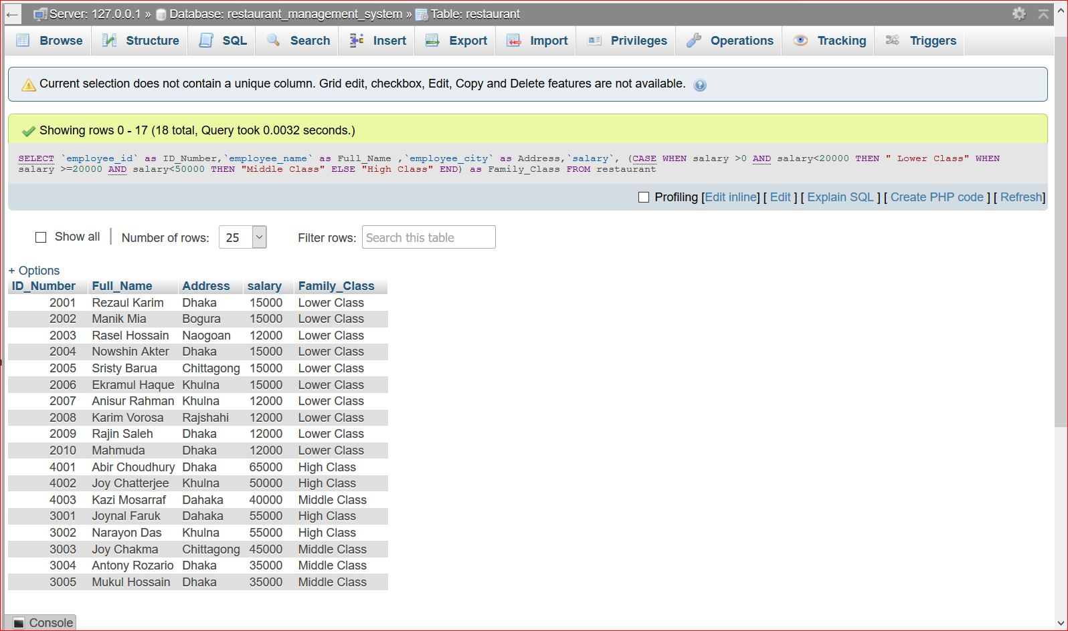

***Inner Join Three Table with Rename and Output:***

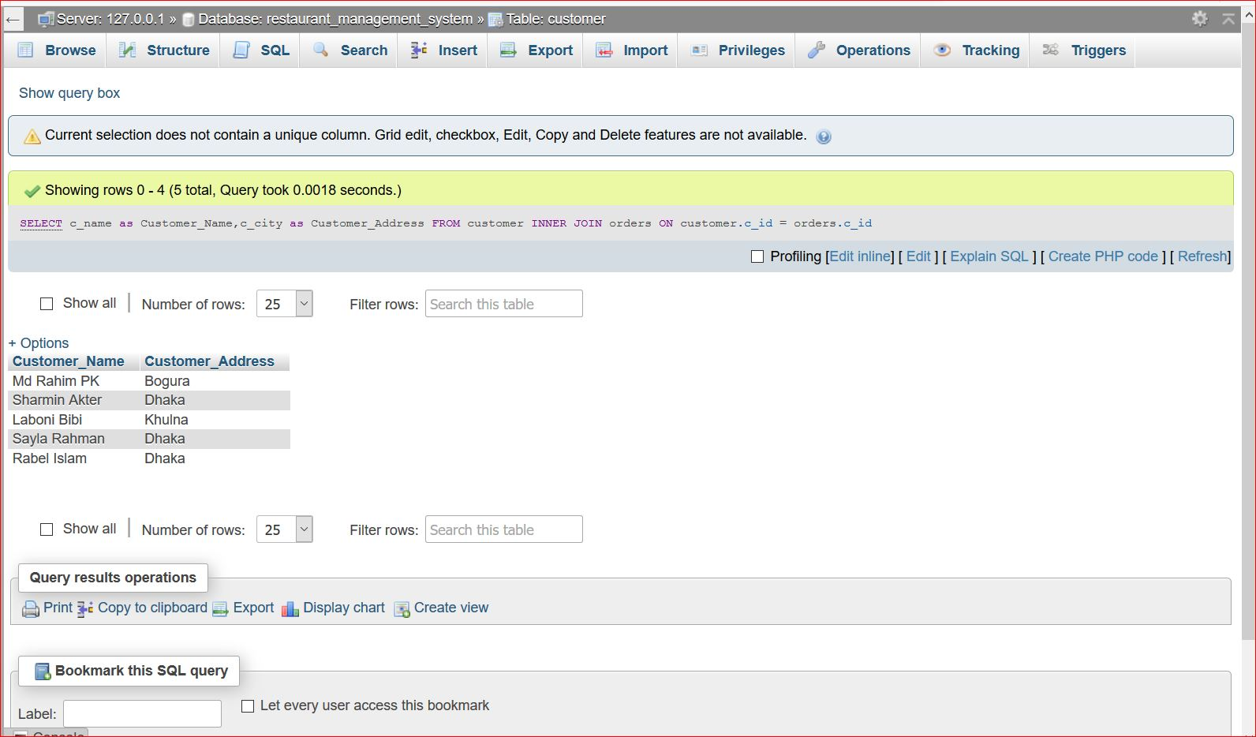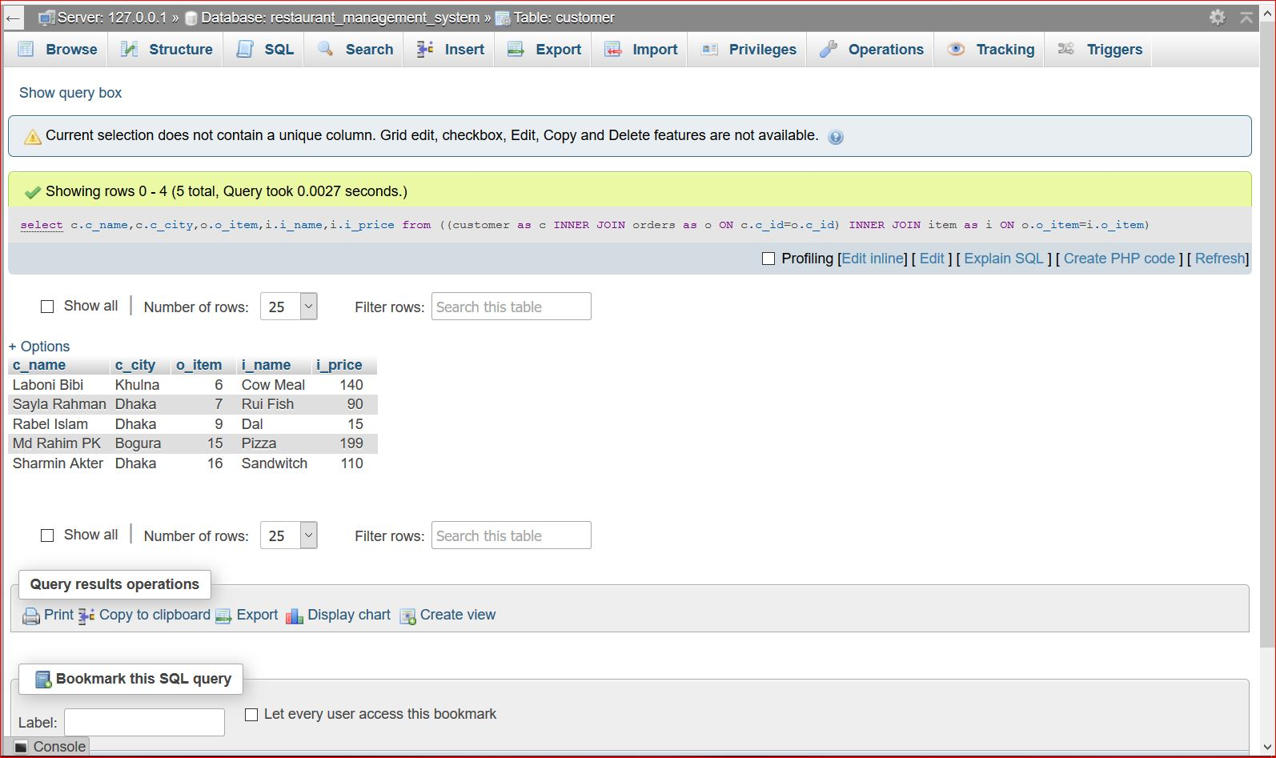

***Natural Join and Output:***

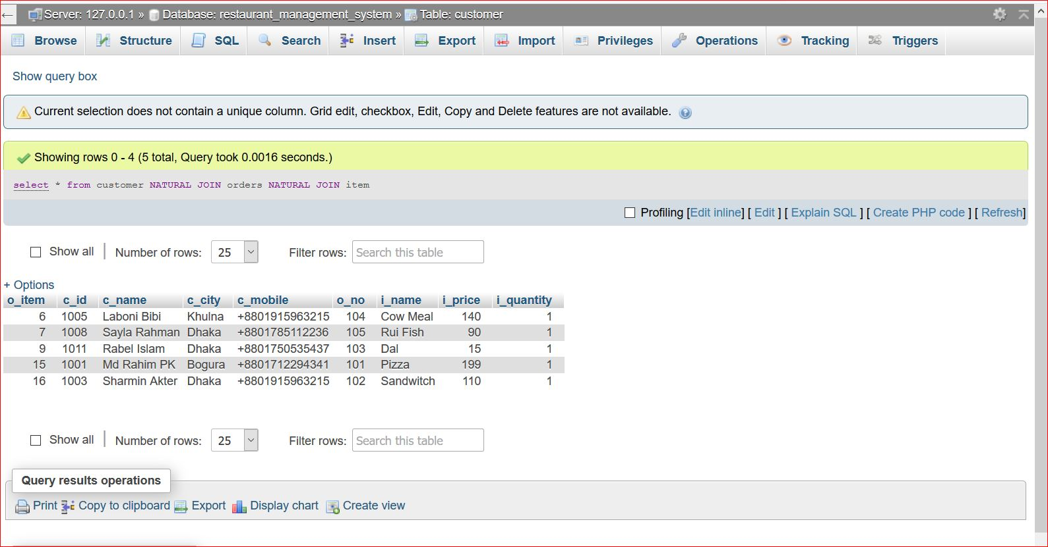

***Union and Output:***

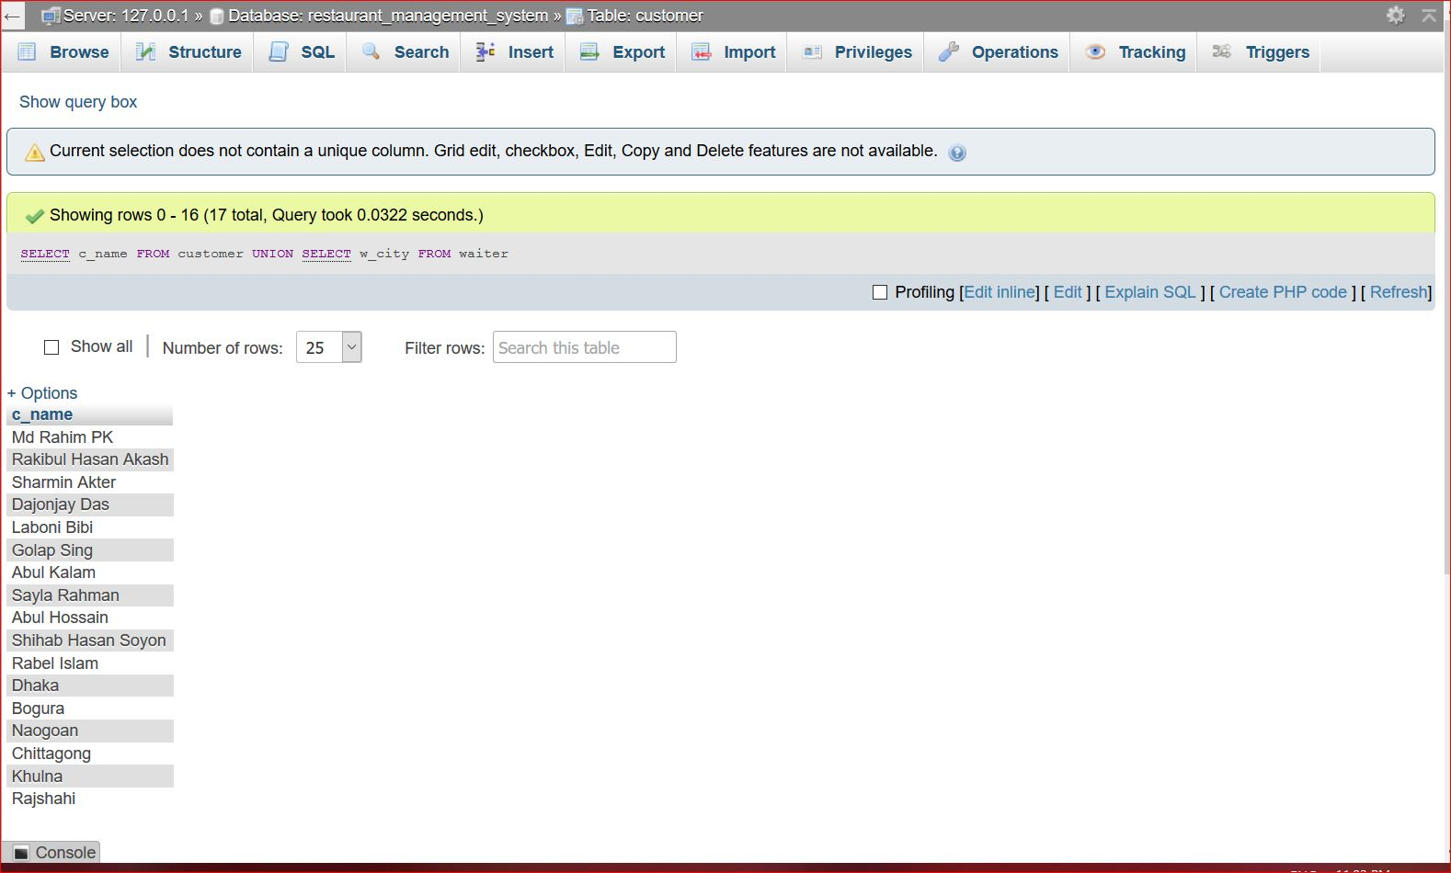

***Update Query and Output:***

*Before: After:*

**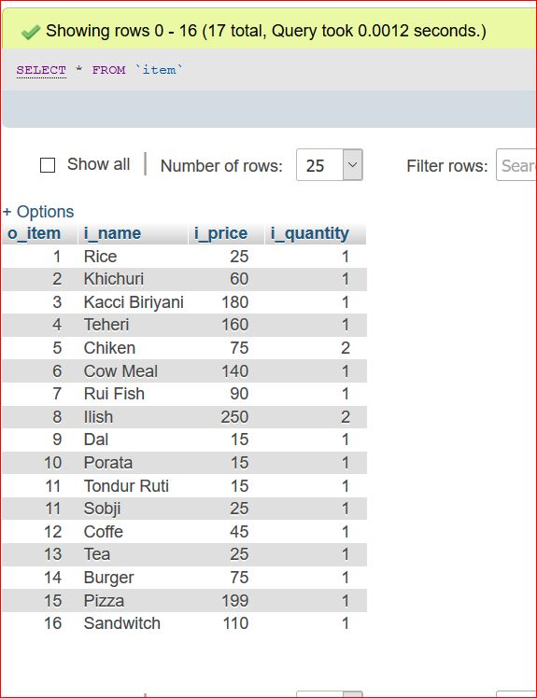*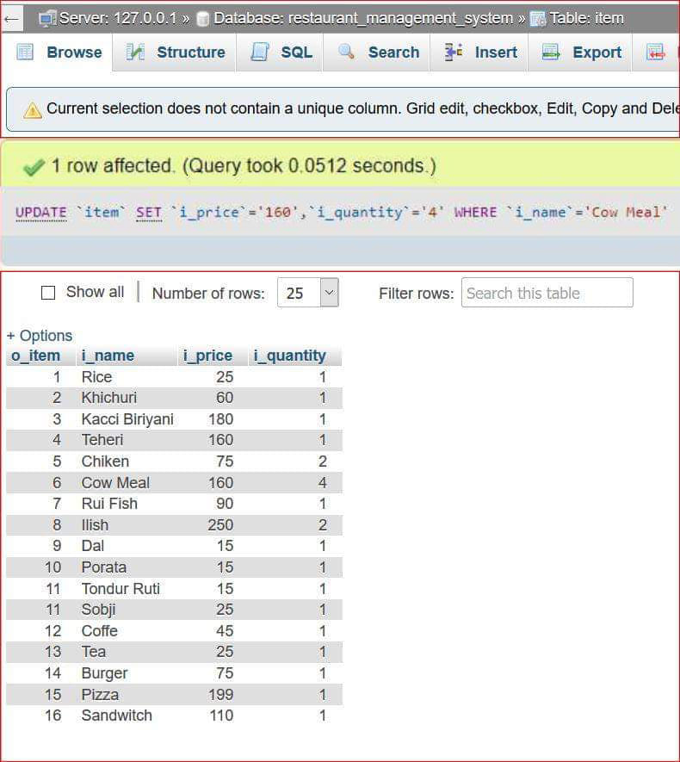***

**ADVANTAGES**

People got to eat! For years upon years, people have been hardwired to grab something to eat when they are hungry. This is a major advantage for any startup restaurant. The only thing you need to consider is the future of your product, and will there be a demand for it in your local geographical area. That’s really it in my opinion. People have to eat and here in the U.S. and around the world is something we all enjoy to do. It’s not like opening a haberdashery. Food is universal, and our very basic senses can lead us there. We’re lucky to live in a country where you can try cuisine from all over the world without having to travel to those parts of the world. When people see a restaurant they know there will be food, but now you have to get them into the door and we’ll discuss marketing later on in this guide.

➢ It increases operational efficiency.

➢ It is designed to help you cost your recipes and track inventory saving your Money and Time and maximizing profit.

➢ It helps the restaurant manager to manage the restaurant more effectively and efficiently by computerizing Meal Ordering, Billing, and Sales Management. Accounting.

➢ It is also designed for inventory control, menu, recipe and liquor costing, nutrition.

➢ It increases the security.

➢ It avoids paper work.

➢ It is Simple to learn and easy to use.

➢ It is portable.

**DISADVANTAGES**

We have sure that most food businesses need a lot of employees to function properly and smoothly with the majority of those workers being low-paid. That leads to a workforce of unreliable employees with a high turnover rate. Finding and keeping qualified employees is a major challenge for the food industry.

Low margins – The food industry is very price sensitive, more so in the world of fast food chains. This leaves you with a very fine line to walk with cost of goods, labor and making a profit. It’s true that food franchises often see high revenues but the net margins are often overlooked. You are also susceptible to food spoilage and theft along with other issues only found in the food industry. I’ve seen anywhere from 4%-11% depending on rent, food and labor cost. We’ll talk more about his later on when negotiating rents and setting up a clear budget.

**FUTURE PLAN**

First we design front for the application with attractive look. The planning stage establishes a bird's eye view of the intended software product, and uses this to establish the basic project structure, evaluate feasibility and risks associated with the project, and describe appropriate management and technical approaches.

Project planning is part of Project Management. It is a well-established approach to managing and controlling the introduction of new initiatives or organizational changes. Projects are finite in length, usually one-time pieces of work involving a number of activities that must be completed within a given time frame, and often on a fixed budget.

While the very simplest projects can be managed easily by applying common sense and just getting on with things, projects that are more complex need a great deal of planning, and benefit from a formal, disciplined management approach. From making sure that activities will actually meet the specified need, to devising a workable schedule, developing systems for reporting progress, and managing requests for changes – all of these issues require thoughtful consideration. Managing projects well requires a great deal of time, skill, and finesse. There are many sides to project management and this is what makes it so interesting and demanding

Application Goals

➢ Profile Management of three categories of users(Administrator, Manager, Service Manager)

➢ Providing different access to different categories of user.

➢ Creating accounts of Customer by using unique Customer ID.

➢ Giving Facility of Home Delivery to Customers.

➢ Giving Facility of Discount.

**FUTURE SCOPE**

This section consist of three components which is *target user***,** *target area* and

*Project deliverables*.

**1. Target User:**

The groups of user that had been identified to use the system are customer and

Administrator.

**ࡽ Customer:**

This user will register to be a member to use the online system of this restaurant management system (RMS). This online ordering divided into two type of custom, it is customer dine-in ordering and takeaway ordering. For dine in ordering, customer will view menu, make online ordering and make a reservation table. But takeaway ordering, customer can view menu and online ordering without reservation table. After customer make online ordering, customer can take ordering the date that customer was choose during make online ordering. Event though, customer must confirmonline ordering with restaurant threedays before customer take the ordering for dine-in customer and for take-away customer will be confirm one hour before it whether by email or phone.

**ࡽ Administrator:**

Administrator is the person who will manage the entire system. This type of user will also do maintenance and control the application of this system. Administrator takes a impossibility to register new customer, register new waiter, register new menu into database, and etc.

**2. Target Area:**

Thissystemwill be placed at restaurant.

**3. Project Deliverables:**

Regarding to the module that had been identified, the flow of an activity will be described in term of customer registration module, customer online ordering and reservation module, waiter module, feedback module, menu module and generate report module.

**ࡾ Customer Registration Module :**

Customer registration module contains customer's information such as customer personal information and other information related to that customer. Then, all of this information recorded into database.

**ࡾ Customer Online Ordering And Reservation Module:**

Customer online ordering and reservation module provides a form that needs to be fulfilling in term of ordering food and reservation table via online.

**ࡽ Waiter Module:**

Waiter module contains waiter information such as waiter personal information, task schedule and other information related to that waiter. Then, all of this information recorded into database.

**ࡼ Feedback Module:**

Based on food or everything about the restaurant, customer can send any suggestion or comment to the restaurant with feedback form. From this form, side of restaurant will know their weaknesses and strengths.

**ࢀ Menu Module:**

Menu module is food that restaurant prepared for customer. This module, customer can view the menu and make decision for order.

**ࡿ Generate Report Module :**

System provides an option for generate a report. The contents of the report as the following:

ⅰ. The report of customer ordering and reservation table.

ⅱ. Customer's information and waiter information.

ⅲ. Suggestion or comment that customer insert at feedback form

ⅳ. W business for restaurant This system will be going to help customer and administrator in restaurant .

Especially part of online ordering and reservation table. Most of restaurant has a problem of the ordering and reservation table. The result of online ordering and reservation table will give customer easy to make ordering and reservation table online and hopefully can smoothen up the job of administrator and waiter. This system also produces a computerized system in defining the best solution in each ordering and reservation problem faces by customer and administrator.

**ࡽ Expected Output:**

The expected output fromthis project is a system that will be able to storecustomer's information, waiter's information, menu's information, store customer information of online ordering and reservation information and customer's suggestion and generate profit business report. Otherwise this system will change form manualsystem to computerized system.

**CONCLUSION**

Restaurant Management System are developed as a system-based. Project objective and project scope identified the Solution for each of the problem. Project Significance also being explains to convince Benefits that can be gathered by the system. This system hopefully canovercome the Problem in the current system.